DIRECTIONS: Complete and hand it in inside your 2 pocket folder along with Unit #1!!
Reflective Portfolio Unit #2: Linear Functions

Section #1: Vocabulary (words and/or diagrams)

Define each:

- Inconsistent Equation - __________________________________________________________

- Identity Equation - ______________________________________________________________

- Average Rate of Change - ________________________________________________________

- Direct Variation - _______________________________________________________________

- Constant of Variation - __________________________________________________________

- System of Equations - ___________________________________________________________

Section #2: Formulas/Equations/Rules

- Average rate of Change

- Slope-Intercept Form of Linear Equation

- Point-Slope Form of Linear Equation

- Direct Variation

Section #3: Key methods and concepts (Show how you arrived at each answer))
- How do you evaluate a piecewise function
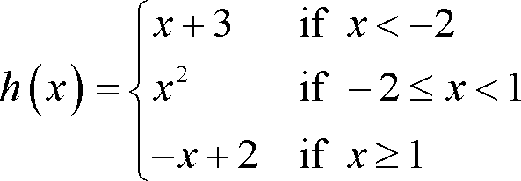
- $h(−2)=$ 3) $h(−1)=$

- $h(1)=$ 4) $h(−5)=$

- How do you graph a piecewise function How do you graph a step function
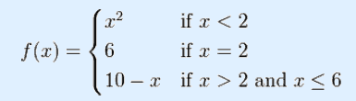
5) 6) $f(t)=\begin{aligned}\left\{3 0<t≤2 | \right\}\left\{6 2<t≤5 | \right\}\end{aligned}\left\{\right\}$
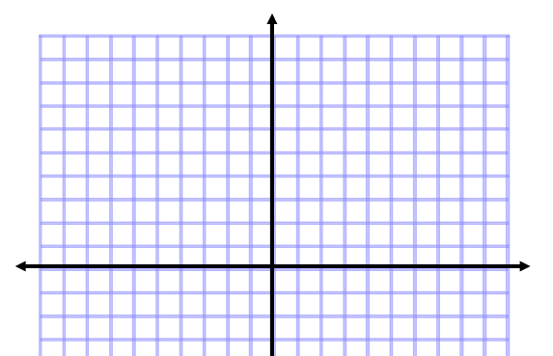
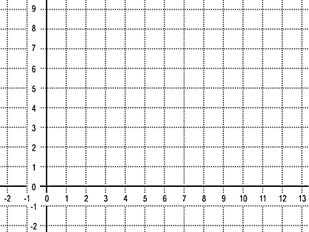

- How can you tell whether the equation is an identity or inconsistent

Circle one:
Solution: Identity Inconsistent Neither

Circle one:
Solution: Identity Inconsistent Neither

Circle one:
Solution: Identity Inconsistent Neither

- $\begin{aligned}−6x+5y+2z=−\text{11} \\ −2x+y+4z=−9 \\ 4x−5y+5z=−4\end{aligned}$How do you solve a system of equations with 3 variables 10)

This study guide needs to be NEAT and ORGANIZED!!! (or you may lose credit)
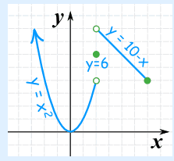
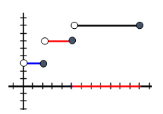
ANSWERS: 1) 4 2) 1 3) 1 4) –2 5) 6)

7) All real #’s – identity
8) no solution – inconsistent
9) x = 2 - neither
10) (4, 3, –1 )

